*The following diagram presents assessments of four countries for:*

* *standard of living (a)*
* *military power (b)*
* *press freedom (c)*
* *diversity of political parties (d)*
* *culture of fear (e)*
* *imperial mindset (f)*
* *strong leader (g)*
* *government propaganda (h).*

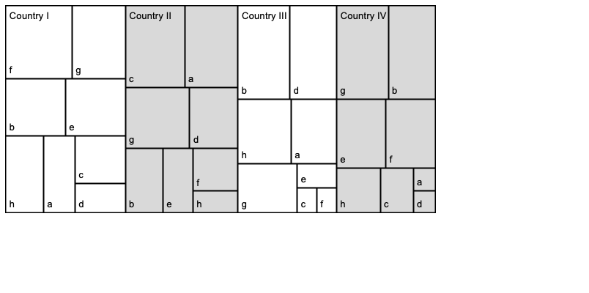

Autocracy is defined by single party dominance, military rule, and a focus on the leader’s personality. All autocracies have the first, along with one or both of the remaining criteria. Countries may become more autocratic if they reduce press freedom, increase government propaganda, deepen a culture of fear in their citizens, or rely more heavily on military power.